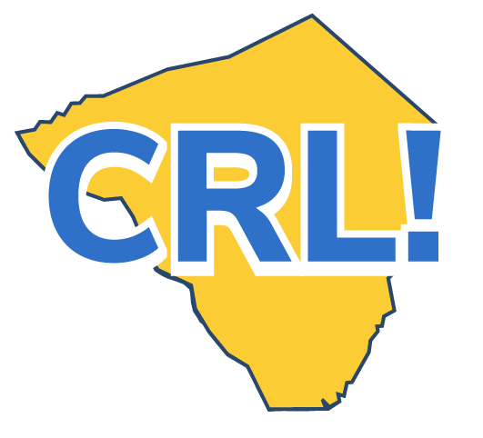
Job Shadow Tip Sheet -Employer

Before the Job Shadow
❒ Provide the School Coordinator with website link(s) about your company, industry, and profession to help the student prepare for the job shadow.
❒ Find out what the student is currently focused on in the classroom so you can link the job shadow to the curriculum.
❏ Ask the coordinator or teacher for tips on how best to interact with the student, and let them know of any concerns you may have.
❒ Let the students know where to go when they arrive at your workplace. If they need identification to enter, be sure to tell them that. Provide a contact name for person they will be meeting with.
During the Job Shadow
❒ Give students instruction in workplace safety, if needed. Include a safety talk at the start of the day and highlight potential hazards.
❒ Be sure the student shadowing you is engaged in a range of activities throughout the day. Try to choose activities that highlight the skills needed to do your job.
❒ Ensure the student cannot inadvertently disrupt or damage your work.
❒ Be ready to adjust the level of difficulty of any shared tasks depending on the student’s abilities.
❒ Share the educational and career path you took to your current position.
❒ Be completely realistic/genuine about pros and cons of the job
❒ Ask questions about what the student shadowing you is learning, and what his/her career aspirations are.
❒ Talk about how school subjects (such as math and language arts) and good habits (such as punctuality and consistent attendance) are important skills in the workplace.
After the Job Shadow
❒ Provide feedback to the coordinator to improve future job shadows using the WBL Activity Evaluation.

Go Deeper
❒ Share a blurb about the job shadow with photos on your company website or social media. Make sure you have school permission to use student photos!
❒ Consider other ways you might use the job shadow to promote your company’s visibility in the community.
❒ Talk to the coordinator about being a classroom speaker, helping with curriculum, or participating in Career Days, Mock Interviews, or Internships.

