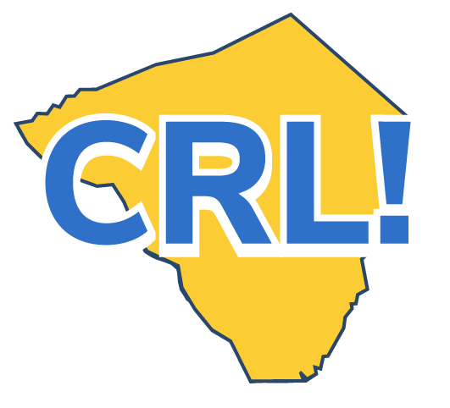
Job Shadow Checklist -Student

A job shadow is a great opportunity to learn about the world of work. You’ll have the opportunity to ask questions, practice professional behavior and become more comfortable communicating with professionals.
Below is a checklist of what you can expect to learn. Read through it and check off what interests you and the goals for the day that are most important to you. Your interests don’t have to be prioritized. If you would like to learn something that’s not listed, just add it!
Have you done all you can to prepare?
❒ Turn in any required forms.
❒ Think about your interests and determine the kind of job you would like to explore or company you would like to visit in your job shadow.
❒ Once chosen, research your host company. Check out their website and learn as much as you can about the organization’s history, what they do, and how it impacts your community.
❒ Meet with your teacher or the coordinator to finalize a learning plan for the job shadow and inquire about what to wear to your job shadow.
Have you thought about what you can do to make the job shadow a big success?
❒ Arrive at the workplace appropriately dressed and on time. Ask the school coordinator what is required as part of your preparation. Attend the orientation if one is offered.
❒ Turn off your cell phone, except to take photos, if the company allows (ask first).
❒ Develop some skill-specific learning outcomes with your job shadow host and work on them.
❒ Comply with all health and safety regulations.
❒ Be observant and ask appropriate questions.
❒ Reflect on the connection between what you are learning in the classroom

When the job shadow is over, how will you keep moving your career forward?
❒ Reflect on the day. Talk to your classmates and teachers about the job shadow and whether you’re interested in pursuing a career in that industry.
❒ Participate in classroom activities that help you think about the value of the job shadow.
❒ Update your Career Portfolio and think about next steps in your career journey.
❒ Send a follow-up email thanking the employer for his or her time.
❒ Fill out any evaluation forms. Be honest. That will help make future job shadows more impactful.

