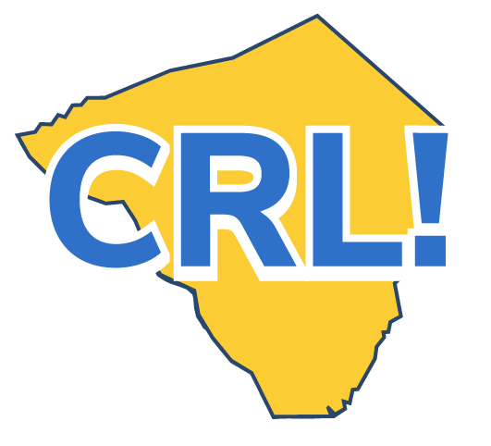
Student Career Day Checklist

On Career Day, you’ll get the chance to learn more about careers that interest you and put careers you haven’t yet heard of on your radar.
You’ll get to ask questions, practice professional behavior and become more comfortable communicating with professionals.
Have you done all you can to prepare for career day?
❒ Fill out any required forms, have them signed and turn them in.
❒ Get the list of visiting companies and do a little research to learn what they do.
❒ Come up with at least three questions you want to ask the employers.
❒ Practice your elevator pitch. Include your name, grade, why you are in this program and what you’d like to do with your future. Summarize your knowledge, skills, accomplishments and anything else that would make an employer see you in a positive light.

Have you thought about what you can do to make career day a big success?
❒ Think of this day as a job interview and dress professionally. Give the employer a good first impression and perhaps a summer job or internship may follow.
❒ When you have the chance, try and find out more about the company by asking one of your prepared questions or any that occur to you. Be enthusiastic (low-energy can come across as lack of interest) and pay attention to what you hear. Can you see yourself working there?
❒ If you don’t yet have a resume, create one and bring copies with you to Career Day so you can hand them out to any employer that interests you.
When career day is over, how will you keep moving your career forward? ❒ Reflect on the day. Talk to your classmates and teachers about the Career Day and if you are interested in pursuing a career in some of the industries represented there. What kind of jobs do you want to know more about? How will you learn about them?
❒ Update your Career Portfolio and think about what you would like to do next to move your career plans forward.
❒ Send a follow-up email to thank each employer for his or her time. If you’re interested in working there or learning more, say so and ask for next steps.
❒ Fill out any evaluation forms. Be honest. That will help make future Career Days more meaningful experiences.

Are you Ready for Game Day?
Have you…
- Turned in your forms?
- Decided what to wear?
- Researched the companies?
- Crafted your questions?
- Polished your resume?
- Practiced your pitch?
- If online, have you done a practice run?
▪ Thought about how you’ll share your day on social media? (Remember to take pics.)

