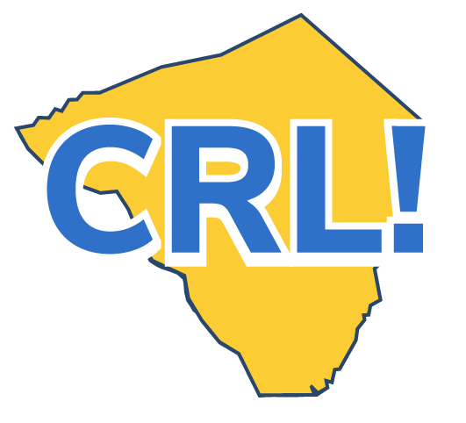
Coordinator Career Day Checklist

Quick tips for School Coordinator to ensure a successful career day.

Before the Career Day
❒ Design the Career Day, working with a committee if one has been established. Choose the date and format, identify goals for the day, create an action plan and schedule planning meetings.
❒ Prepare teachers and encourage them to participate before, during and after the Career Day.
❒ Have teachers help create learning objectives and work with students to prepare for the day and create questions they can ask.
❒ Keep principal and staff well informed and publicize the event at staff meetings and in school announcements. Create a Career Day flyer and post several around the school and on the school website.
❒ Provide employers an information packet about the school, including the format and schedule of events for the day. Share itinerary/program and agenda with employers one week in advance.
❒ Confirm employer attendance and determine presentation needs. Let them know where to park, and share any visitor procedures they need to follow.
❒ Make sure the employer volunteers are supported and prepared. Share questions to expect and encourage them to create an engaging and interactive presentation—using visuals and props if possible.

During the Career Day
❒ Be the point person and troubleshooter on Career Day. Be prepared to address technology issues and have a back-up plan in case the speaker cancels.
❒ Distribute a schedule of events for the day to all parties.
❒ Arrange for the employer volunteers to be met and escorted to the correct location.
❒ Distribute and collect feedback surveys.
After the Career Day
❒ Document the Career Day. Review all feedback surveys and summarize results. Debrief the day and make recommendations for improvements.
❒ Help students update their Career Portfolio and think about any next steps they would like to take to further their career goals.
❒ Work with teachers to coordinate “go deeper” activities to connect Career Day to the classroom. ❒ Take pictures from Career Day and provide them to the companies for their websites or newsletters. Ensure you have signed releases for all photos.
❒ Publicize the Career Day and the businesses in attendance by placing a story in the local newspaper or posting on the school website.
❒ Consider other public relations benefits and opportunities

Sample Career Day Timeline
- Beginning of the school year: Brainstorm business partners who could participate. Find a location.
- Two months in advance: Invite business partners to participate. Secure date, time and location.
- One month in advance: Meet with the planning committee to review logistics and facility needs. Confirm participation of speakers.
- One week in advance: Send planning brief to speakers with agenda for the day, logistics, event information and questions to expect. If conducting the career day online, test and practice with the selected platform.
- On Career Day: Welcome presenters and manage event flow and agenda.

