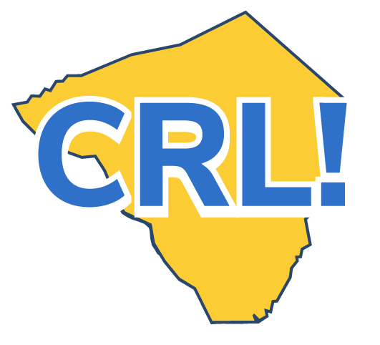
Career Day Student Reflection Activity

Take some time to think about Career Day and reflect on how it might affect your college and career plans in the future.

Student name: | School:
Name of one Career Day presenter you spoke to:
Company of presenter:

What aspects of the Career Day were interesting? Why? Be specific.

What aspects of the Career Day were not interesting? Why not? Be specific.

What did you learn about the presenter’s company? Please explain.

How does the presenter use skills like reading and math in his/her career?

What were the steps that the presenter took to get to his/her current career?

Would you consider a career in this field? Why or why not?

If you wanted to pursue this career option, what might you do to prepare in the next five years, both in high school and afterwards?

