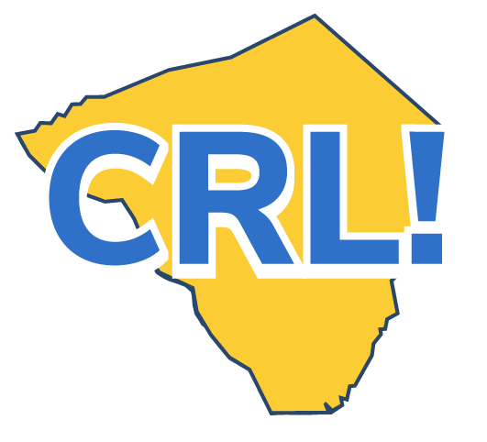
Business Tour Tip Sheet - Teacher

Note: If you are coordinating the tour, have a look at the School Coordinator Site Visit Checklist.

Site Visits are Designed to:
● Provide exposure to the industry sector, potential career opportunities, and jobs.
● Expand occupational knowledge.
● Build an understanding of the education and training needed for entry into careers in the industry.
● Foster an understanding of the business’s workforce and its contributions to the community.

Before the Site Visit
❒ Review the Site Visit Fact Sheet and assess how a tour can support classroom
activities and help meet curriculum goals.
❒ Review the plan for the tour with the coordinator and determine where you
can be helpful.
❒ Identify and document desired student learning objectives.
❒ Discuss expectations for the tour with students and point out what they might
learn from it
❒ Have students research the employer and prepare at least three meaningful
questions to ask during the tour. What do they want to know about the company
and the industry?
❒ Collect signed permission forms.
During the Site Visit
❒ Support the employer by making sure students are attentive, polite, and engaged.
❒ Help connect what you see at the workplace with classroom topics.
After the Site Visit
❒ Provide individual and group reflection activities for students. Help them make the connection between the classroom and the workplace.
❒ Support students in updating their Career Portfolio and determining their next steps in learning about careers.
❒ Provide feedback to help assess the impact and value of the tour, document
and archive information about the tour.
❒ Have students write thank-you notes to the employer partner.

Go Deeper
❒ Guide students through a comparison of the culture and style of the workplace with others they have observed, including behavioral and communication expectations.
❒ Make the tour part of a project and have students prepare and deliver a presentation to others at your school about the company.
❒ Take pictures from the tour and provide them to the company for their
website or newsletter. Ensure you have signed releases for all photos.
❒ Publicize the tour and business by placing a story in the local newspaper or
posting on the school website.

