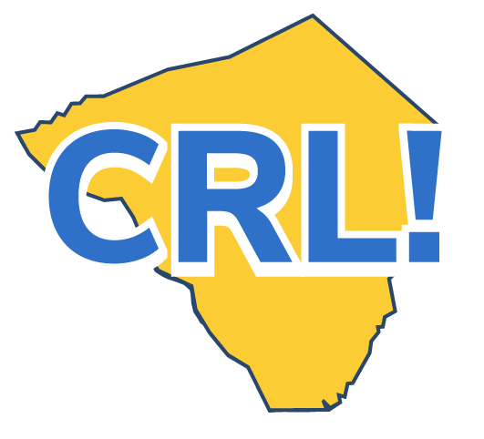
Business Tour Tip Sheet - School Coordinator

Before the Site Visit
❒ Identify the appropriate employer contact and work with them to plan the tour, providing materials and support where needed.
❒ Suggest that the employer bring in someone from the HR team to talk about entry-level recruitment.
❒ Arrange for transportation, permission slips, food and other logistics.
❒ Find out if safety gear is required and, if so, arrange for it to be provided.
❒ Talk with teachers about how a Site Visit can help students meet curriculum goals and make the classroom connections.
❒ Prepare students by having them research the company and practice their personal introductions.
❒ Identify and document desired student learning objectives.
During the Site Visit
❒ Work with the tour host. Make sure to provide time for an introduction, an overview of the business and its operations and what to expect during the tour.
❒ Ensure students and teachers receive instruction in workplace safety and orientation to workplace norms.
❒ Structure the tour so students see the full spectrum of activities and occupations within the company.
❒ Help ensure that students can observe and interact with employees at different levels of responsibility in the organization.
❒ If possible, have students experience some hands-on activity during the tour. ❒ Have students experience the tour in small groups and ask questions as they arise.
After the Site Visit
❒ Help students connect what they’re learning in class to what they experienced on the tour.
❒ Provide individual and group reflection activities for students.
❒ Support students in determining their next steps in learning about careers.
❒ Debrief with the tour host.
❒ Have the students write thank-you letters.
❒ Assess the impact and value of this tour and utilize employer, teacher, and student feedback to improve future tours. Document and archive information.
❒ Help students update their Career Portfolio and think about any next steps they would like to take to further their career goals.
Go Deeper
❒ Make the tour part of a project and have students prepare and deliver a presentation about the company after the tour.
❒ Have students create a presentation about their career pathway and deliver it to the employer partner during the tour.
❒ Take pictures from the tour and provide them to the company for their website or newsletter.
❒ Publicize the tour and the business by placing a story in the local newspaper or posting on your webpage. (Make sure you clear this with the employer partner first.) ❒ Consider other potential public relations benefits and opportunities.

