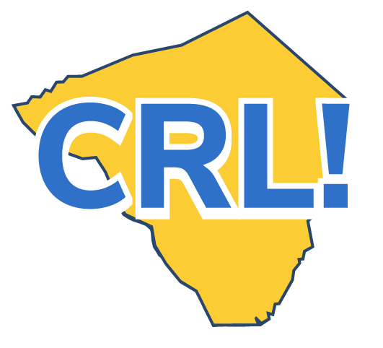
Business Tour Fact Sheet -Employer

On a Site Visit, students visit a workplace, learn about the business, meet employees, ask questions, and observe work in progress.
More than a simple field trip, a Site Visit is designed and structured to meet specific learning outcomes, be educationally rich, and build awareness of the business, its industry sector, its role in the economy, and the career options it provides.
Why are Site Visits important for students?
● Provides exposure to potential careers and jobs and helps identify potential interests as well as those occupations not of interest.
● Builds occupational knowledge and familiarity with the education and training needed for success in the industry.
● Helps make the connection between academic theory and practical application.
● Creates awareness of the business’s role in the community, as well as its functions, processes, products, and employees.
What are the benefits to my company?
● Exposes potential future workers to job opportunities and careers with your company.
● Introduces your employees to students, which helps them understand how to communicate with the next generation of workers.
● Helps current employees feel good about the company’s commitment to education and the community.
● Promotes an understanding of the role and contributions of your business.
What do I need to do next?
● Contact your Employer Coordinator
● Arrange for a presentation to those of your employees who will be hosting the tour.
● Consider any impacts on company policy.
Resources
● Distribute the Employer Site Visit Tip Sheet to interested employees.

