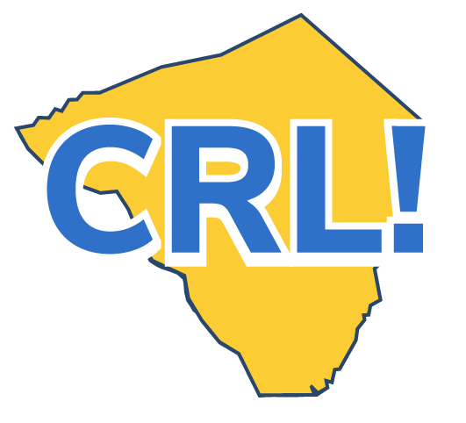
Business Tour Checklist - Student

When you get the chance to go on a Site Visit, you’ll look behind the scenes of a business or company and ask yourself if this is somewhere you can see yourself in the future. Keep the following things in mind as you get ready for the tour.
Have you done all you can to prepare for the Site Visit?
❒ Turn in all required forms.
❒ Learn what the dress code is for the place you’re visiting.
❒ Research the company—how they got started, the kinds of jobs they have and how they contribute to their community.
❒ Think about what you want to learn and come up with at least three questions about the company or the careers it offers.
❒ Practice your elevator pitch. Include your name, grade, why you are in this program and what you would like to do with your future.
❒ Summarize your knowledge, skills, accomplishments and anything else that would make an employer see you positively.
Do you know what you need to do during the Site Visit?
❒ Pay attention to what’s going on at the worksite. Can you see yourself working in a place like this? What kinds of jobs are you interested in?
❒ Actively participate. Ask the questions you came up with and any others that will help you determine if a career in this industry is for you.
❒ See if you can connect what’s going on in the workplace with what you’re learning in school.

When the Site Visit is over, how will you keep moving your career forward?
❒ Talk to your classmates and teachers about the Site Visit and your feelings about pursuing a career in that industry. What kind of jobs do you want to know more about? Would you be interested in going on another tour in the future? What kind of education will it take to get there?
❒ Write a thank-you note to the people who hosted the tour.
❒ Fill out the tour evaluation. Be honest. What worked for you? That will help improve future tours.
❒ Update your Career Portfolios profile and think about any next steps you would like to take to further your career goals.

