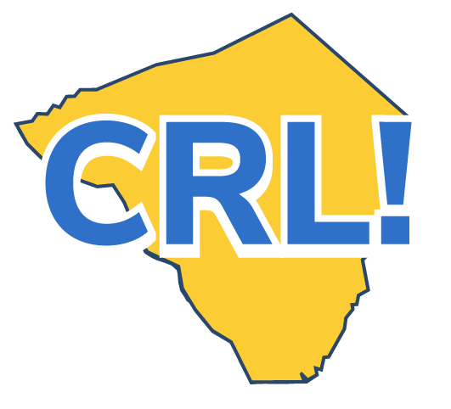
Teacher Career Day Tip Sheet
Note: If you’re coordinating a Career Day, have a look at the School Coordinator Career Day Checklist.

Career Days are designed to:

▪ Expose students to a variety of careers and jobs by connecting them with business partners.
▪ Provide a realistic picture of the workplace.
▪ Help students make the connection between school and the workplace.
▪ Inform career planning.
Before Career Day
❒ Review the Career Day Fact Sheet and Teacher Tip Sheet. ❒ Assess how the day can support classroom activities and help meet curriculum goals.
❒ Identify desired student learning objectives and talk to the students about the day and what they can expect to learn.
❒ Share the list of visiting companies and have the students research their websites and prepare at least three questions for each employer.
❒ Build excitement for the day. Help students think about how it connects to their career goals. Collect any required forms.
❒ If online, practice using the technology, including how students will ask questions and interact with employers.
During Career Day
❒ If employers are visiting the classroom, introduce the speaker(s) and help moderate the session. Keep an eye on the time for each visitor’s discussion and wrap up the day with thanks to all.
❒ If the Career Day is taking place in the auditorium or large meeting space, help students navigate the room and approach visitors professionally.
❒ If the Career Day is taking place online, troubleshoot any technology issues.
❒ Distribute and collect feedback forms from students and speakers.
After Career Day
❒ Provide individual and group reflection activities for students and help them make the connection between training topics and the workplace.
❒ Help students update their Career Portfolios and think about any next steps they would like to take to further their career goals.
❒ Have students write thank-you notes to the employer partners.
❒ Assess the impact and value of the Career Day with the coordinator and utilize employer, staff, and student feedback to improve future Career Days.
❒ Document and archive information about Career Day.
Go Deeper
❒ Make the Career Day part of a project and have students prepare and deliver a presentation to others at your school about one or more of the companies that visited.

The Classroom Connection: Preparation and Reflection
The day before Career Day Set students up for success by having them.
▪ Research visiting Career Day speakers.
▪ Prep their resume.
▪ Practice their elevator pitch. ▪ If online, practice using the platform with your
students.
After Career Day
▪ Spark student reflection with an activity.
▪ Ask, “What new things did you learn about jobs and
industries?”
▪ Ask if they want to find out more?

